V.L Memorial Public School
475 Vijay Nagar
Chapter - 9 - Class 8th Maths
CLASS 08 - MATHS (GANITA PRAKASH)

 | Single Mark Questions
1 | Multiple Choice Questions  - Fermat’s Last Theorem states that the equationx$​^{n}$ + y $​^{n}$ = z $​^{n}$ has no solution in natural numbers for  - a) n = 1  - b) n > 2  - c) n ≥ 2  - d) n = 2  - In the given figure,$ABCD$ is a square. If $AC=5\sqrt{2} cm$ , then perimeter $ABCD=$ ________.  - 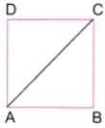  - a) $20\sqrt{2} cm$  - b) 10 cm  - c) 20 cm  - d) $20\sqrt{5} cm$  - The diagonal of a rectangle is 13 cm and one side is 5 cm. Find the other side.  - a) 10 cm  - b) 8 cm  - c) 9 cm  - d) 12 cm  - Two squares have side lengths 4 cm and 7 cm.  - What is the side of the square formed by Baudhāyana’s method?  - a) $\sqrt{65}$ cm  - b) 5 cm  - c) $\sqrt{33}$ cm  - d) 11 cm  - If the area of a square is 18 cm², what is the area of the square constructed on its diagonal?  - a) 36 cm²  - b) 9 cm²  - c) 12 cm²  - d) 18 cm²  - Baudhāyana’s method of combining two different squares uses which geometric figure as the key step?  - a) Equilateral triangle  - b) Parallelogram  - c) Rectangle  - d) Right - angled triangle  - If two squares of sides a and b are combined using Baudhāyana’s construction, the area of the new square is  - a) ab  - b) (a + b)²  - c) a² + b²  - d) a² - b²  - The hypotenuse of an isosceles right triangle is$\sqrt{50}$ cm. Find the length of one equal side.  - a) $\sqrt{36}$ cm  - b) 5 cm  - c) 10 cm  - d) $\sqrt{100}$ cm  - A square has side 5 cm. A new square is constructed on its diagonal. What is the area of the new square?  - a) 25 cm²  - b) $5\sqrt{2}$ cm²  - c) 50 cm²  - d) 10 cm²  - In the given figure,$ABCD$ and $APQC$ are squares. If area $APQC=98sq.cm$ , then $AB=$ ________.  - 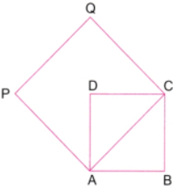  - a) 7 cm  - b) 49 cm  - c) $70\sqrt{2} cm$  - d) 14 cm  - If the side of a square is 8 cm, what is the area of the square obtained by the halving construction?  - a) 32 cm²  - b) 16 cm²  - c) 64 cm²  - d) 128 cm²  - In an isosceles right triangle, each equal side is 6 cm.  - Find the length of the hypotenuse.  - a) 12 cm  - b) 6$\sqrt{2}$ cm  - c) 3$\sqrt{2}$ cm  - d) 18 cm  - Check whether (9, 40, 41) is a Baudhāyana triple.  - a) No  - b) Only if it is scaled  - c) Only if it is primitive  - d) Yes  - The diagonals of a rhombus are 24 cm and 70 cm.  - What is the length of its side?  - a) 37 cm  - b) 35 cm  - c) 47 cm  - d) 41 cm  - Which of the following triples is primitive?  - a) (6, 8, 10)  - b) (12, 16, 20)  - c) (9, 12, 15)  - d) (5, 12, 13)  - Which relation is always true for an isosceles right triangle with equal sides a and hypotenuse c?  - a) c² = a²  - b) c = 2a  - c) c² = 2a²  - d) c = a + 2  - Two shorter legs of a triangle are 7 cm and 24 cm. Which conclusion is correct?  - a) It is not a right - angled triangle.  - b) Its hypotenuse is 25 cm.  - c) Its hypotenuse is not a whole number.  - d) Its sides do not form a primitive Baudhayana triple  - In the given figure AC = ________. 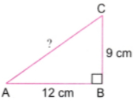  - a) 21 cm  - b) 25 cm  - c) 22 cm  - d) 15 cm  - Why is the square formed by joining the midpoints of the sides of a square a square?  - a) All its sides are equal and its angles are right angles  - b) Its diagonals are unequal  - c) Its perimeter is half  - d) All its sides are horizontal  - Which of the following is a primitive Baudhayana triple?  - a) (10, 24, 26)  - b) (8, 15, 17)  - c) (9, 12, 15)  - d) (6, 8, 10) | [20]
2 | Fill in the blanks with suitable words  - The numbers 8, 15, and 17 form a ________ Baudhayana triple.  - The area of the square produced by the hypotenuse of a right triangle is the sum of the areas of the squares produced by________.  - In an isosceles right triangle with equal sides a, the hypotenuse c is given by c = ________.  - If the side of a square is a, then the length of its diagonal is ________.  - The longest side of a right - angled triangle is called the________.  - In a right triangle, the hypotenuse is the side opposite to the________.  - ABCD is a square. Its diagonals meet at O. The area of the square with AO as a side will be ________the area of square ABCD.  - If two squares have sides a and b, the side of the square formed by Baudhāyana’s method is ________. | [6]
3 | Assertion Reason  - Assertion(A): In a right triangle, the hypotenuse is always the longest side.  - Reason(R): The Baudhayana theorem states that the square of the hypotenuse is equal to the sum of the squares of the other two sides.  - a) Both A and R are true and R is the correct explanation of A.  - b) Both A and R are true but R is not the correct explanation of A.  - c) A is true but R is false.  - d) A is false but R is true.  - Assertion (A): In an isosceles right triangle, the hypotenuse is always longer than each of the equal sides.  - Reason (R): In an isosceles right triangle, the hypotenuse is equal to twice the length of each equal side.  - a) Both A and R are true and R is the correct explanation of A.  - b) Both A and R are true but R is not the correct explanation of A.  - c) A is true but R is false.  - d) A is false but R is true.  - Assertion (A): (7, 24, 25) is a primitive Baudhayana triple.  - Reason (R): 7, 24, 25 are co - prime numbers.  - a) Both A and R are true and R is the correct explanation of A.  - b) Both A and R are true but R is not the correct explanation of A.  - c) A is true but R is false.  - d) A is false but R is true.  - Assertion (A): If the side of a square is doubled, the square constructed on its diagonal also has double the area of the original square.  - Reason (R): The diagonal of a square of side a is $a\sqrt{2}$ .  - a) Both A and R are true and R is the correct explanation of A.  - b) Both A and R are true but R is not the correct explanation of A.  - c) A is true but R is false.  - d) A is false but R is true.  - Assertion (A): The diagonal of a rectangle can be found using the Baudhāyana - Pythagoras theorem.  - Reason (R): A rectangle can be divided into two right - angled triangles by its diagonal.  - a) Both A and R are true and R is the correct explanation of A.  - b) Both A and R are true but R is not the correct explanation of A.  - c) A is true but R is false.  - d) A is false but R is true.  - Assertion(A) : If the sides of a right - angled triangle are in the ratio $3:4:5$ , then the triangle is a scaled version of a triangle formed from a primitive Baudhayana triple.  - Reason (R): Any triangle whose sides are proportional to a Baudhayana triple satisfies the relation $a^{2}+b^{2}=c^{2}$ .  - a) Both A and R are true and R is the correct explanation of A.  - b) Both A and R are true but R is not the correct explanation of A.  - c) A is true but R is false.  - d) A is false but R is true.  - Assertion (A): The square formed by joining the midpoints of the sides of a square has half the area of the original square.  - Reason (R): The diagonals of the original square are equal in length.  - a) Both A and R are true and R is the correct explanation of A.  - b) Both A and R are true but R is not the correct explanation of A.  - c) A is true but R is false.  - d) A is false but R is true.  - Assertion (A): Every Baudhāyana (Pythagorean) triple is a primitive triple.  - Reason (R): A primitive Baudhāyana triple has no common factor greater than 1.  - a) Both A and R are true and R is the correct explanation of A.  - b) Both A and R are true but R is not the correct explanation of A.  - c) A is true but R is false.  - d) A is false but R is true.  - Assertion (A): The sum of the areas of the squares with sides 5 cm and 12 cm is equal to the area of a square with a side of 17 cm.  - Reason (R): Baudhayana theorem.  - a) Both A and R are true and R is the correct explanation of A.  - b) Both A and R are true but R is not the correct explanation of A.  - c) A is true but R is false.  - d) A is false but R is true. | [9]
4 | Very Very Short Questions  - Name the mathematician who proved Fermat’s Last Theorem in 1994.  - If a right - angled triangle has a short side of length 12 cm and the hypotenuse of length 37 cm, find the length of the remaining side.  - The diagonals of a rhombus are 10 cm and 24 cm. Find the length of one side.  - Two squares have sides 3 cm and 4 cm. Find the side of the square formed by Baudhāyana’s method.  - Write one primitive Baudhāyana triple having numbers less than 15.  - If the hypotenuse of an isosceles right triangle is$10\sqrt{2} cm$ , find the length of each equal side.  - Find the hypotenuse of an isosceles right triangle whose equal sides have a length of$4\sqrt{2} cm$ . | [7]
 | Section B
5 | Very Short Questions  - In a right - angled triangle, if one leg is 3 cm and the other leg is 4 cm, what is the length of the hypotenuse?  - 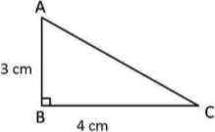  - The lengths of the diagonals of a rhombus are 16 cm and 12 cm. Find the length of the side of the rhombus.  - A person walks 5 km east and then 12 km north. Find the straight - line distance from the starting point to the final position.  - Write a scaled triple using multiplication for (13, 84, 85) using  - multiplication  - division  - Find the diagonal of a square with a side length of 7 cm.  - If a square has an area of 8 sq. units, find the area of a square constructed on its diagonal.  - Find the bounds of$\sqrt{2}$ up to three decimal places.  - Is (5, 12, 13) a primitive Baudhāyana triple? What are the other primitive Baudhāyana triples with numbers less than or equal to 20? | [16]
 | Section C
6 | Short Questions  - Find the area of the shaded region. 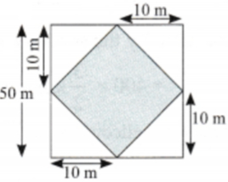  - Two poles of heights 6 feet and 12 feet stand on a plane ground. If the distance between the feet of the poles is 8 feet, find the distance between their tops.  - The hypotenuse of an isosceles right triangle is$\sqrt{162}$ units. Find its other two sides.  - Show$\sqrt{2}$ cannot be written as a fraction.  - Let a, b and c denote the length of the sides of a right triangle, with c being the length of the hypotenuse. Find the missing sidelength ina = 1.5, b = 3.5.  - A rhombus has diagonals of length 16 cm and 12 cm. Find the length of each side of the rhombus.  - A rectangular park is 80 m long and 60 m wide. A person walks diagonally across the park. What distance does the person cover?  - 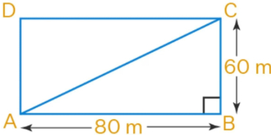  - Is there an unending sequence of Baudhāyana triples?  - Let a, b and c denote the length of the sides of a right triangle, with c being the length of the hypotenuse. Find the missing sidelength ina = 5, b = 7.  - The area of a square built on its diagonal is 32 sq. cm. Find the perimeter of the square. | [30]
 | Section D
7 | Long Question Answers  - The length of the two equal sides of an isosceles right triangle is given. Find the length of the hypotenuse. Find bounds on the length of the hypotenuse such that they have at least one digit after the decimal point.  - 3  - 4  - 6  - 8  - 9  - Construct a square whose area is equal to the difference of the areas of squares of sidelengths 5 units and 7 units.  - Find the hypotenuse of an isosceles right triangle with equal sides of length 1 unit. What is the value of$\sqrt{2}$ ?  - 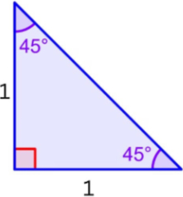  - How can one construct a square having double the area of a given square? Explain Baudhāyana’s method.  - If a right - angled triangle has a short side of length 8 cm and hypotenuse of length 17 cm, what is the length of the third side? Again, try drawing the triangle and measuring, and then check your answer using Baudhāyana’s Theorem.  - If a right - angled triangle has a short side of length 9 cm and hypotenuse of length 15 cm, what is the length of the third side?  - 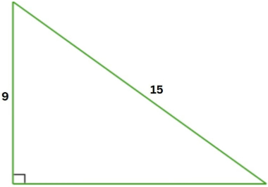  - Using the dots of a grid as the vertices, can you create a square that has an area of (a) 2 sq. units, (b) 3 sq. units, (c) 4 sq.units, and (d) 5 sq. unit?  - 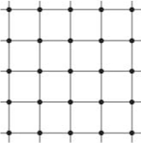  - Verify whether the triple (5, 12, 13) is a Baudhāyana triple.  - Find the hypotenuse of this isosceles right triangle.  - 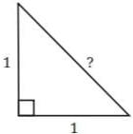  - A lotus flower is peeping out of water with its tip 1 unit above the water. When swayed by a breeze, the tip touches the water 3 units away from its original position. Find the depth of the lake.  - 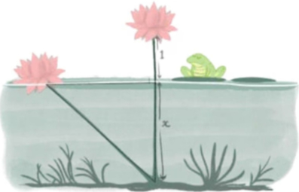 | [50]
 | Section E
8 | Case Based Questions  - Read the following text carefully and answer the questions that follow:  - The study of Baudhāyana triples inspired the great French mathematician Pierre de Fermat in the 17th century to make a remarkable observation. Since there are infinitely many integer solutions to a² + b² = c², Fermat wondered if similar solutions exist for higher powers. He asked: Can we find positive integers satisfying a³ + b³ = c³? Or a⁴ + b⁴ = c⁴? In the margin of a book, Fermat wrote that no such solutions exist for any power greater than 2, claiming he had a "truly marvellous proof" but the margin was too small to contain it. This became known as Fermat’s Last Theorem. For over 350 years, mathematicians tried to prove it. Finally, in 1994, Andrew Wiles, who had been fascinated by this problem since age 10, succeeded in proving it. Questions:  - What is Fermat’s Last Theorem stating about the equation aⁿ + bⁿ = cⁿ for n > 2? (1)  - Name the mathematician who finally proved Fermat’s Last Theorem and in which year. (1)  - Verify that (3, 4, 5) satisfies a² + b² = c² but does not satisfy a³ + b³ = c³. (2)  - OR  - Explain why (3k, 4k, 5k) for any positive integer k gives infinitely many solutions to a² + b² = c², but no such pattern exists for higher powers according to Fermat’s Last Theorem. (2)  - Read the following text carefully and answer the questions that follow:  - Baudhāyana, in his ancient text Śulba - Sūtra (c. 800 BCE), posed an interesting question: How can one construct a square having double the area of a given square? A common mistake is to simply double the side length, but this actually creates a square with four times the area. Baudhāyana provided an elegant solution: the diagonal of a square produces a square of double the area. When we draw a square on the diagonal of the original square, the new square has exactly twice the area. This can be verified by drawing horizontal and vertical lines through the vertices, which reveals that the original square contains two congruent triangles, while the larger square contains four such triangles. This geometric insight forms the foundation for understanding the relationship between the side and diagonal of a square. Questions:  - If you double the side length of a square, how many times does its area become? (1)  - What is the length of the diagonal of a square with side length 5 cm? (1)  - A square has area 18 sq. cm. What is the length of its side? What would be the area of the square drawn on its diagonal? (2)  - OR  - Using Baudhāyana’s method, show that if a square has side length ’a’, then the square on its diagonal has area 2a². Explain with a diagram. (2)  - Read the following text carefully and answer the questions that follow:  - In an isosceles right triangle, the two legs are equal in length. Baudhāyana’s theorem helps us find the length of the hypotenuse. Consider an isosceles right triangle with equal sides of length 1 unit. A square of side 1 unit is made of two such triangles. The square constructed on the diagonal of this square has twice the area. Therefore, if the hypotenuse is ’c’, then c² = 2, so c = $\sqrt{2}$ . This number $\sqrt{2}$ is fascinating - it lies between 1.4 and 1.5, and its decimal expansion (1.41421356...) never terminates. Moreover, $\sqrt{2}$ cannot be expressed as a fraction of two integers, making it an irrational number. Questions:  - In an isosceles right triangle, if the equal sides are 7 units each, what is the length of the hypotenuse? (1)  - Between which two integers does$\sqrt{2}$ lie? (1)  - If the hypotenuse of an isosceles right triangle is 12 units, find the length of its equal sides. (2)  - OR  - Prove that $\sqrt{2}$ cannot be expressed as a terminating decimal. Use the method of finding bounds to show that 1.414 < $\sqrt{2}$ < 1.415. (2) | [15]

